AutoML: Automating the Traditional Machine Learning
Methodology

Dr. Suboh M Alkhushayni

ABSTRACT
Machine Learning has revolutionized most of the industries. Organizations belonging to different domains using Machine Learning to automate the process of making better business decisions. Due to the lack of expertise and human resources in nontechnical domains, Machine Learning as a Service (MLaaS) is used by domain experts which automates the machine learning modelling and deploying process called Automated Machine Learning (AutoML). In this paper, we provide the architecture, methods and applications of AutoML and demonstrate the implementation of AutoML in real time.
The pipeline includes an AutoML Guardrails module that checks for cross-fold duplicates, group leakage, temporal leakage, and path/token leakage in image datasets before any model is trained. All preprocessing steps—imputation, scaling, polynomial features, binning, and VIF-based multicollinearity filtering—are fit strictly inside each training fold using scikit-learn Pipelines and ColumnTransformers, ensuring leakage-free cross-validation. The system standardizes experiments across four modern AutoML frameworks (AutoGluon, LightAutoML, H2O AutoML, FLAML) and three strong boosting baselines (XGBoost, LightGBM, CatBoost) using identical dataset splits, fixed time budgets, and repeated CV. Metrics such as Accuracy, F1, ROC-AUC, RMSE, inference latency, and model size are logged for every run.
To support rigorous evaluation, the benchmark computes per-fold results, bootstrap 95% confidence intervals, and paired statistical tests. Explainability is integrated through SHAP and LIME, while deployment readiness is demonstrated through model packaging (.pkl, .json, .yaml), latency measurements, FastAPI endpoints, and a Streamlit leaderboard. All code, configurations, and scripts are publicly available, making the system reproducible, extensible, and suitable for both learning and real-world applications.
Keywords: AutoML, Data Leakage, Cross-Validation, Boosting, Explainability, Deployment, Reproducibility.

1. INTRODUCTION

1.1 MOTIVATION
Machine learning is now used in almost every field, including healthcare, finance, retail, transportation, and education. Although machine learning delivers powerful results, building a complete and reliable model still requires deep technical knowledge, careful data preparation, and a lot of time. A typical workflow involves collecting data, cleaning it, engineering features, selecting algorithms, tuning hyperparameters, validating the model, and finally deploying it into a real application. For many organizations, especially those without dedicated data science teams, this process is difficult to perform correctly and consistently.
One of the biggest challenges in real-world machine learning is data leakage, which happens when information from the validation or test set accidentally influences the model during training. Leakage can occur in subtle ways, such as fitting an imputer or scaler before splitting the data, leaving duplicates in both train and validation folds, or allowing time-based patterns to leak across chronological boundaries. Image datasets can also leak label information through folder names or file paths. If leakage is not detected, the model appears much better than it truly is. This creates unrealistic expectations, unreliable decisions, and results that cannot be reproduced.
Another challenge is that many AutoML tools focus mainly on accuracy and ignore important deployment metrics like inference speed, model size, and resource usage. A model with high accuracy may still be unusable if it is too slow in production or too large to deploy on limited hardware. Along with this, many tools lack full reproducibility—users often cannot recreate the original results because configuration files, dataset versions, or seed settings are missing.
The motivation behind this project is to solve these problems by building a leakage-audited, modular, and fully open-source AutoML system. Our pipeline performs strict fold-aware preprocessing, runs modern AutoML frameworks and boosting models under identical conditions, calculates detailed metrics (including latency and model size), and generates explainability outputs. The system ensures that all experiments are reproducible and deployment-ready, making AutoML more trustworthy and easier to adopt for both technical and non-technical users.

1.2 WHAT IS AutoML
Automated Machine Learning (AutoML) is the process of automating the work done by the data scientists. Data Scientists are the people who perform the complicated tasks ranging from data collection, data preprocessing and feature engineering to model deployment. AutoML is a computer program or an application which serves as a pipeline [6] between human domain experts and a deployed application. Using AutoML approach one can automate the process of data preprocessing, feature engineering, model generation and evaluation.
In this project, AutoML acts as a unified system where different frameworks—such as AutoGluon, LightAutoML, H2O AutoML, and FLAML—run under the same settings. This allows fair comparison between models and makes the entire process faster, more consistent, and easier to use.

1.3 THE NEED OF AutoML
The AutoML approach is considered to be more accurate and can sometimes outperform machine learning engineers. To reduce the costs for setting up resources to design wellperformed models [10], a new idea of automating the whole pipeline process of machine learning i.e., AutoML emerged in the industry and academia. By using AutoML, it is possible and practical to combine different techniques dynamically to form an end-to-end and easy-to-use pipeline system [10]. Many AI companies have developed such systems (e.g. AutoML by H2O [3]) to help people with little or even no machine learning knowledge to build the highquality custom models.

2. RELATED WORK
The various approaches for implementing AutoML methodology, there are two[7] approaches for model selection: traditional model selection method which selects the best-performing model from the various machine learning algorithms like k-nearest neighbor, support vector machine, decision trees etc. Model selection can also be done by using Auto-sklearn which is automated model selection approach. Meta-learning [2] and NAS [1] (neural architectural search) are used for modelling the data after performing feature engineering.
The AutoML frameworks uses the pipeline. After obtaining the dataset, the pipeline performs the following tasks
Data Preparation: The first step every machine learning pipeline must perform is data preparation or data preprocessing. In this step a robust AutoML tools perform data cleaning, data scaling and transformation before it is used for generating features [10].Data Preparation is the process of cleaning and combining the data for feeding it to the machine learning model, the raw data is transformed into a single source file after removing redundancy, handling missing values, treating outliers and scaling the data values onto one standard format.
Feature Engineering: Feature engineering generally include feature selection, extraction and construction, Feature extraction and construction are the other forms of feature transformation which eventually leads to the creation of new set of features. [9] The training data consist of rows and columns that can be used to extract more features for increasing the accuracy, it is done by extracting the new features from the existing apparent features. The feature engineering increases the predictivity of machine learning algorithm.
Data Modeling: After the features are generated, the next step is to generate the model and set the hyperparameters. In the AutoML setup [5], the task is to automatically select classifiers and set their hyperparameters so that good learning performance can be obtained.
Continuous Delivery Pipeline: The process of automation should be improving by repeating and reiterating the dataset [7]. By this way, our work can be scaled to MLaaS (Machine Learning as a Service) category. A few ways to reiterate the dataset is using Cross-Validation technique, Grid Search Method and TestTrainSplit + Bootstrapping.
Model Deployment: According to the CRISP-DM methodology, each machine learning problem must have the end results. The pipeline should provide the decision making strategy for each dataset provided. The AutoML process is made to replace the role of data scientists so that everyone without any knowledge of Data Science and little domain knowledge [7]. Model Deployment can be done in various ways like providing an excel file, providing a documentation file, LaTeX file. Our work is to provide the .PKL and excel file convertible to JSON/YAML file as end results so user can scale the process to a Machine Learning Web
Application.
Modern AutoML Frameworks and Boosting Models: In recent years, several modern AutoML frameworks have been introduced to make machine learning even easier and more reliable. Tools such as AutoGluon[12], LightAutoML, H2O[3] AutoML, and FLAML automate advanced steps including hyperparameter tuning, ensembling, and model comparison. These frameworks help users build strong models with less manual effort and are commonly used in both research and industry. Along with AutoML frameworks, boosting algorithms like XGBoost, LightGBM, and CatBoost[13] have become important baselines in AutoML studies. These models are known for producing high accuracy on tabular datasets and for handling missing values and categorical features effectively. Because of their strong performance, boosting methods are often included when evaluating or comparing AutoML systems.

3. METHODS

3.1 THE ARCHITECTURE OF AutoML
The architecture of the system is designed as a step-by-step automated pipeline. It begins with dataset discovery, followed by guardrail checks that detect common forms of data leakage. Clean data then moves through preprocessing and feature engineering before passing to model training. After training, the system performs statistical evaluation, generates explainability outputs, and exports deployment-ready artifacts.
The same pipeline is used for AutoGluon, LightAutoML, H2O AutoML, FLAML, XGBoost, LightGBM, and CatBoost, ensuring fairness across all experiments.

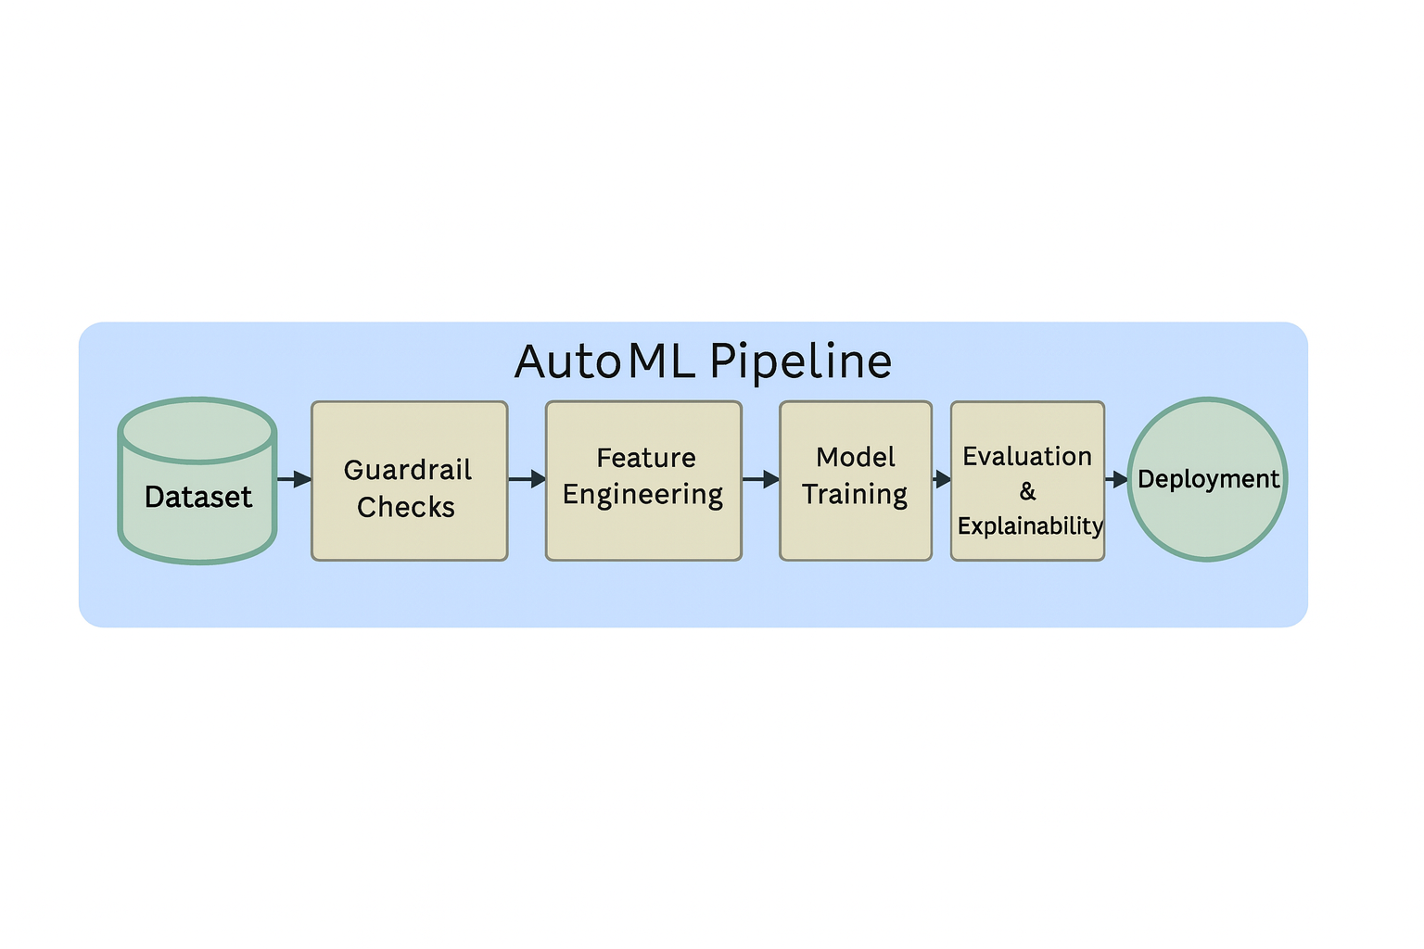
Figure 1. Architecture of AutoML
3.2 PROJECT TEMPLATE AND FILE HIERARCHY:
The project follows a clean and organized folder layout to support clarity, reproducibility, and ease of use. The Project/experiments directory contains all preprocessing steps and AutoML wrapper functions, while Project/trainers includes the boosting model trainers and framework runners. The scripts folder holds automation utilities such as run_all.py, guardrail checks, and analysis scripts. All experiment outputs, including metrics, tables, figures, and explainability results, are stored inside the reports directory. The Deploy folder contains FastAPI configuration files along with Docker and Compose setups for model serving. Finally, the data directory manages raw datasets as well as intermediate processed versions. This structured layout makes the workflow easy to understand and extend, allowing users to navigate the system efficiently and maintain consistent experiment management.
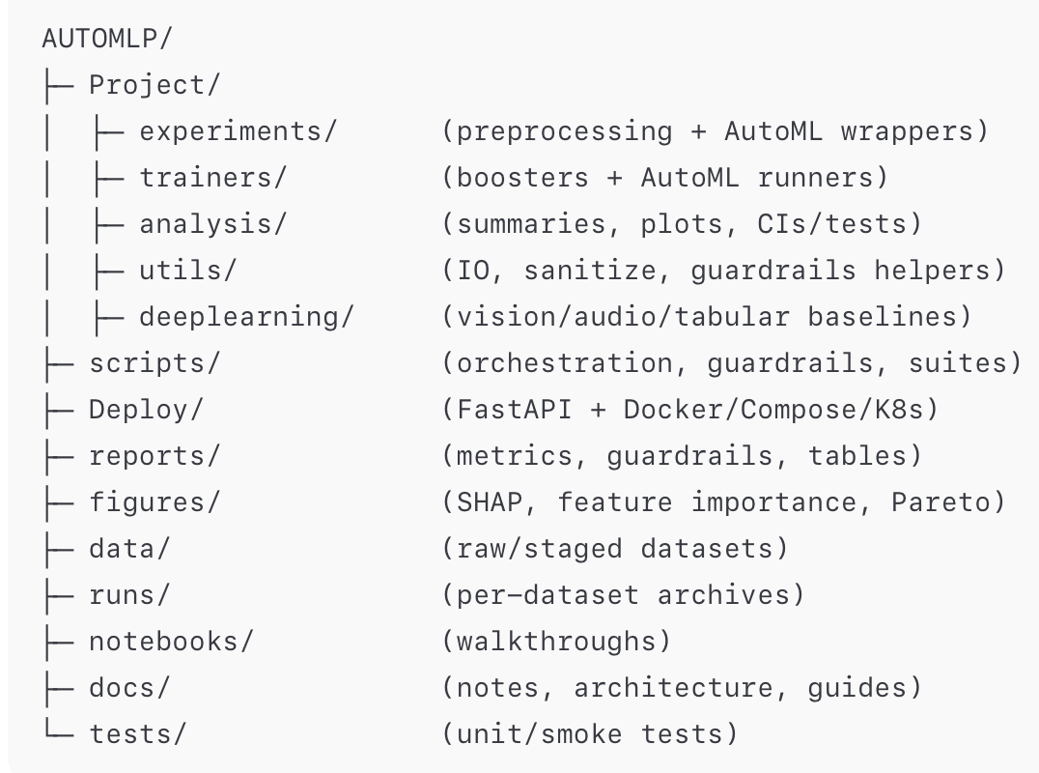

Figure 2: File Hierarchy System

3.3 Requirements File
The requirements file is a text document that contains the required packages and libraries to run the project. In the project, Python programming language is used and hence the requirement.txt contains all the packages and libraries build on Python programming language. The requirement file includes (but not limited to) Python Machine Learning Library, Python Data Analysis Library, Python Numerical Programming Library, etc.
Numpy, matplotlib, scipy, scikit-learn, Jupyter, requests, pandas, seaborn, click, openpyxl, watermark, engarde, scikit-plot, tqdm are the libraries and packages used in the project.
IN addition, The file includes the core machine learning libraries such as pandas, numpy, scikit-learn, and matplotlib, along with the boosting algorithms XGBoost, LightGBM, and CatBoost. It also contains modern AutoML frameworks including AutoGluon, LightAutoML, H2O AutoML, and FLAML, which are used throughout the project for benchmarking and model comparison. Additional libraries such as SHAP, FastAPI, Streamlit, and PyYAML support explainability, deployment, configuration management, and visualization

3.4 DATA COLLECTION
Data Collection module is a pipeline that is used in the AutoML project that will help to extract the data according to the requirements of the modeling process, This module will help to collect the data and gather it into a single file, if the data is coming from more than a single source and then transform it on the model. In practicality, Data Collection Module is the Python class in which there are seven functions, also known as extractors or collectors are used to extract or collect the data from the different sources. Sources include the following:


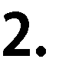
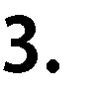
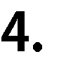


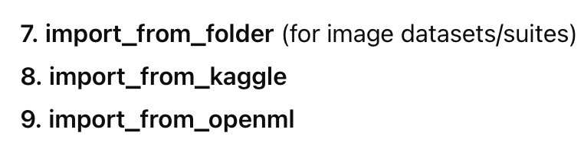

3.5 DATA PROCESSING
The data cleaning module performs all the basic and necessary preprocessing steps in a single pipeline, using one Python function inside a class. This function reads the data file from the selected source and applies several cleaning operations automatically. These include treating missing values, calculating missing value percentages, reshaping the dataset when required, displaying unique values for each feature, and showing the data types of all columns. The module also computes descriptive statistics such as minimum, maximum, mean, and standard deviation for numerical attributes. After completing these steps, the Python class returns a clean and well-structured data frame that is ready for feature engineering and model training.

3.6 INITIAL EXPLORATION

The Initial Exploration module performs basic exploratory data analysis (EDA) to help users understand the structure and quality of the dataset before modeling. This step includes generating summary statistics such as minimum, maximum, mean, median, and standard deviation for numerical columns, as well as listing the unique values for categorical features. The module also provides information about the number of rows, number of columns, missing value percentages, and overall dataset shape. These outputs help confirm that the dataset was loaded correctly and is ready for preprocessing and feature engineering. By automating this step, the system gives users a quick overview of the dataset without requiring manual inspection.

3.7 VARIANCE INFLATION FACTOR
The Variance Inflation Factor (VIF) module is used to detect and reduce multicollinearity among numerical features. High multicollinearity can destabilize certain models by inflating variance and making coefficients unreliable, especially for linear or generalized linear models.
VIF is used to calculate the multicollinearity in a set of a multiple columns or features in a dataset. Mathematically VIF formula is
VIF(j) = 1 / 1-RSquare(xj)

3.8 NEW FEATURE GENERATION
e feature generation module applies optional transformations designed to enrich the input space and improve model performance. This includes polynomial feature expansion (e.g., interaction terms, squared features) and KBins discretization, which groups continuous values into quantile-based or uniform bins. All transformations are performed in a fold-aware manner: the parameters for bins, interaction features, and scaling are learned only from the training fold and applied to the validation fold to prevent leakage.
This module will basically help to create the more features on top of the features that are already available initially, Polynomial Factor etc. techniques will be used in this process pipeline ax2 + bx + c = 0

3.9 CLASSIFIER MODULE
This will be a single python class or pipeline that will perform the classification algorithms on the dataset, this module will include all the major classification algorithms and it will show the combined results of all the classifiers.
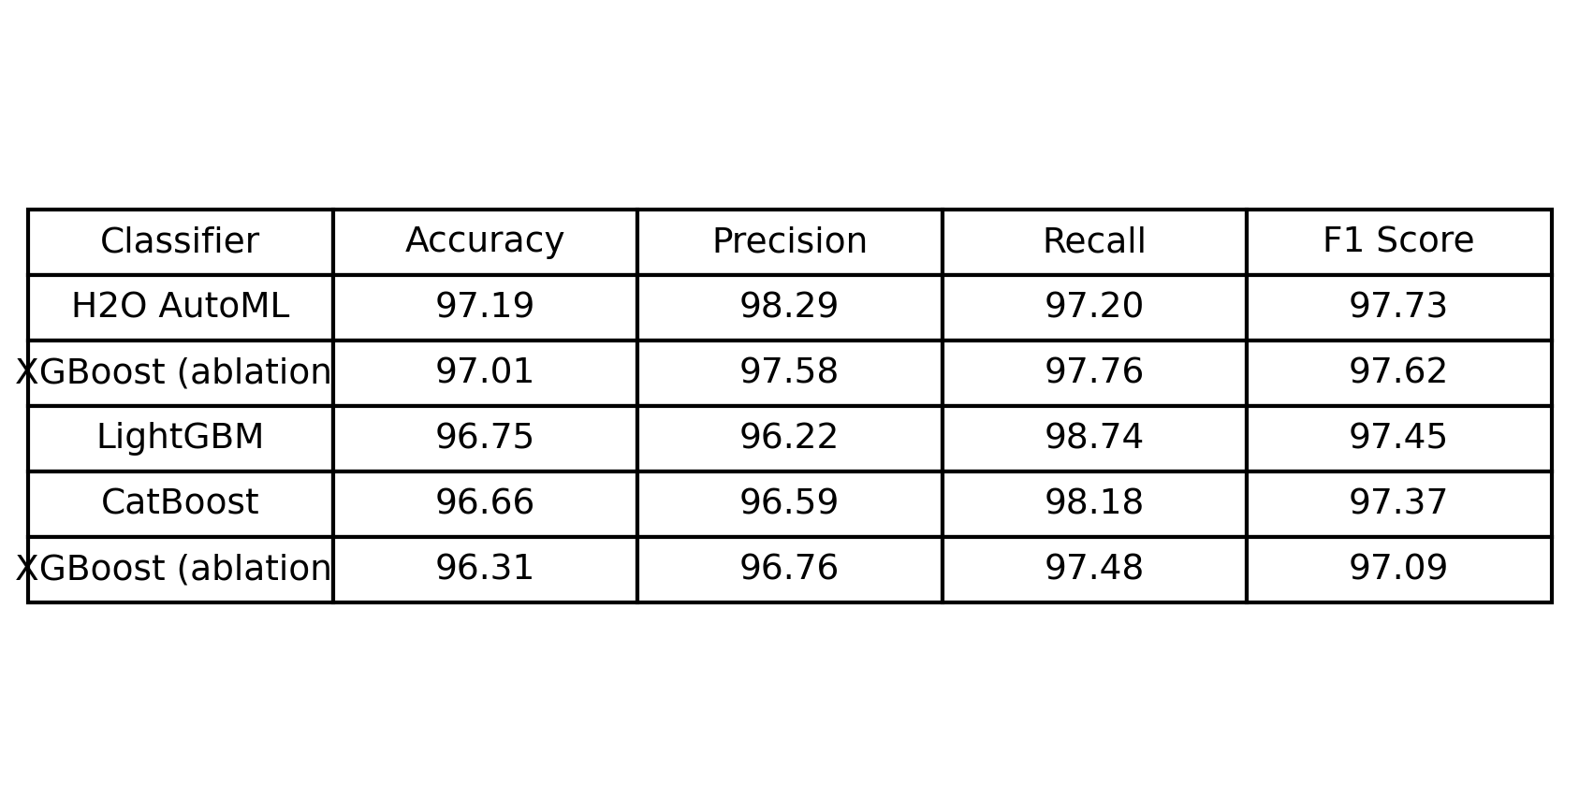
Figure 3: Classification Evaluation Results
3.10 CROSS-VALIDATION AND LEAKAGE CONTROL:
The benchmark uses a consistent cross-validation strategy to evaluate all models fairly. For classification tasks, the system mainly relies on StratifiedKFold, which preserves the class distribution in each fold; for regression or other tasks it uses standard KFold. The number of folds and random seeds are defined in the configuration file so that every framework and booster trains on the exact same splits. This makes the comparison between AutoML tools and boosting models more meaningful, because differences in performance are not caused by different train–validation partitions.
All preprocessing steps are designed to be fold-aware to prevent data leakage. Imputers, scalers, encoders, polynomial feature generators, KBins discretizers, and the optional VIF filter are fit only on the training portion of each fold and then applied to the corresponding validation portion. No information from the validation data is used when learning parameters such as mean, standard deviation, or bin boundaries. In addition, a separate AutoML Guardrails module runs before splitting to detect common leakage patterns, including cross-fold duplicates, group or ID leakage, temporal or look-ahead leakage, and path/token leakage for image datasets. Any issues are reported as JSON files in the reports/guardrails directory with severity levels and suggested fixes, helping users keep the experiments honest and reproducible.
3.11 HYPERPARAMETER BUDGETS AND FAIRNESS CONTROLS
To ensure fair comparison between different models and frameworks, the project applies explicit budget and configuration rules. All AutoML frameworks—AutoGluon, LightAutoML, H2O AutoML, and FLAML—are run under the same time budgets (typically 300–600 seconds per dataset) and use the same cross-validation splits and seeds. Within that time limit, each framework is free to search over its own model families and hyperparameters, but none is allowed additional runtime or extra data. This setup mirrors how AutoML tools are used in practice while keeping the benchmark balanced.
The boosting baselines (XGBoost, LightGBM, CatBoost) use sensible, documented hyperparameter configurationsrather than extreme tuning. Key parameters such as learning rate, maximum depth, number of estimators, and regularization settings are chosen based on common best practices and are kept consistent across datasets unless otherwise noted. Hardware details—such as CPU model, RAM, and whether GPU acceleration is used—are recorded so that results can be interpreted in context and reproduced on similar machines. Together, these fairness controls make the reported performance differences easier to trust, because they are driven by the modeling approaches rather than by hidden advantages in time, tuning effort, or resources.
3.12 Datasets and Tasks:
The benchmark covers a mix of tabular classification and regression datasets, image classification datasets such as CIFAR-10, and lightweight audio datasets like the Free Spoken, Digit Dataset (FSDD) or torch audio speech commands. For each dataset, key statistics are tracked, including the number of samples, the number of features for tabular data, and the number of images or audio clips and classes for vision and audio tasks. These choices provide diversity in modality and problem difficulty while keeping experiments computationally manageable.
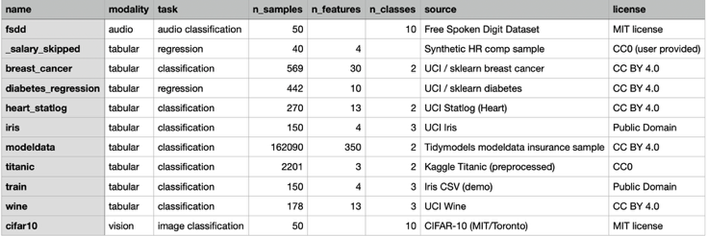
Figure 4: Datasets
3.13 METRICS AND STATISTICAL TESTING
The evaluation module measures model performance using standard machine-learning metrics. For classification tasks, the system records Accuracy, Precision, Recall, F1 Score, and ROC-AUC (or PR-AUC for imbalanced problems). Each metric is computed per fold and then averaged across all folds using the same random seeds. Results are saved to reports/metrics, where they are aggregated into a ranked performance table showing the top-performing models.
A high-resolution summary table is generated automatically and saved as a PNG image in ../figures/paper, making it easy to include as a figure in the research paper. The system also supports deeper statistical analysis, including mean ± standard deviation, bootstrap-based 95% confidence intervals, and paired significance tests such as the Wilcoxon signed-rank test. Additional deployment-relevant measurements, such as training time, inference latency, and model size, can also be recorded when available.
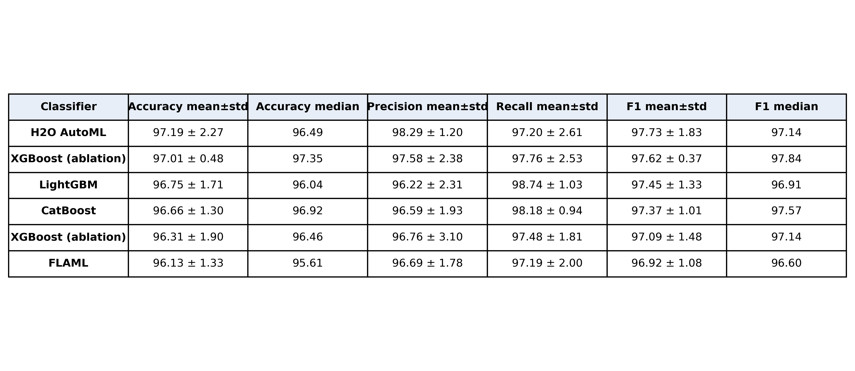
Figure 5: Classification Results
3.14 EXPLAINABILITY
The benchmark uses SHAP (SHapley Additive exPlanations) to provide consistent global and local feature attributions across boosting models, ensembles, and AutoML frameworks that support probability outputs. SHAP is applied during evaluation to help interpret how each model uses the input features. For every trained model, the pipeline generates a global SHAP summary plot, which ranks features by their overall contribution to predictions, and can also produce local SHAP force plots for explaining individual samples. These visualizations help illustrate why certain features influence predictions more strongly than others and reveal differences in how models learn—for example, CatBoost’s specialized handling of categorical variables versus the stacked-ensemble architectures used by AutoGluon or LightAutoML.
All explainability outputs are automatically stored in the figures/shap/ directory. This allows users to easily browse, compare, and include the figures in their reports without manually exporting them. The SHAP summary plot is typically used as the primary explainability figure for the Methods or Results section.
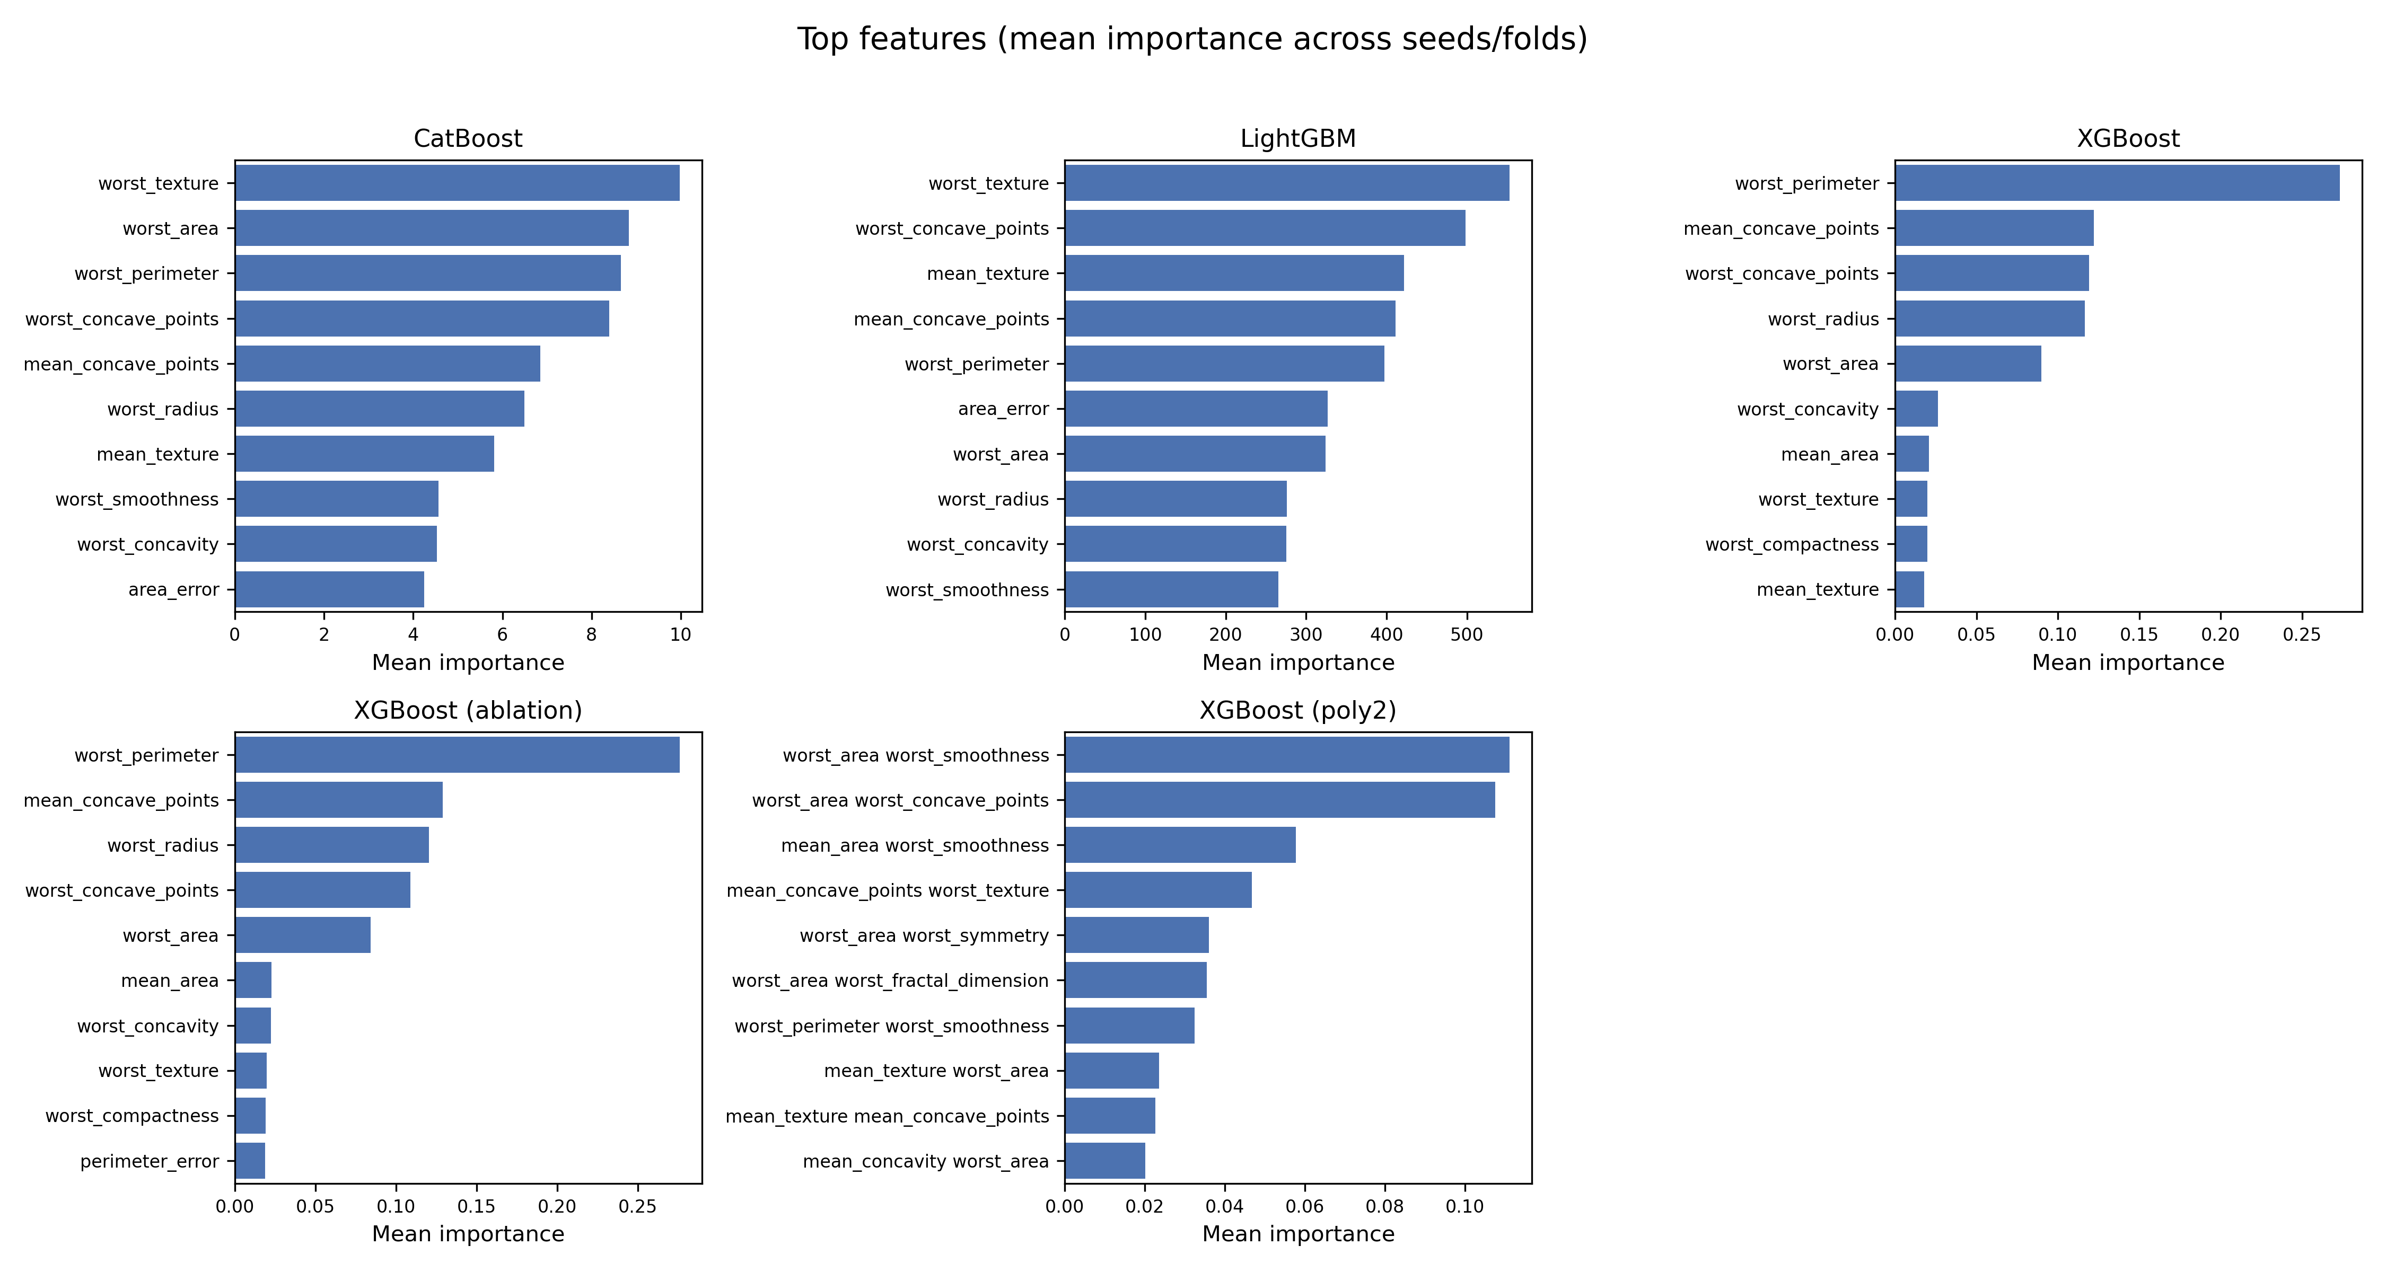
Figure 6: SHAP summary plot showing global feature

3.15 RESOURCE USAGE AND DEPLOYMENT READINESS

To support real-world applications, the system also evaluates how efficient each model is during deployment. This includes measurements such as training time, prediction latency, resource usage, and final model size. These values help determine not only how accurate a model is, but also how practical it would be to run in production settings. Performance and efficiency metrics are saved automatically so they can be reviewed later.

In addition to evaluation, the benchmark includes a basic deployment setup. Trained models can be exported in common formats such as .pkl, .json, or .yaml, making them easy to integrate into other applications. The project also provides an example API service for model predictions, along with optional containerization files to simplify running the system in different environments. A small dashboard is included to help users browse model outputs, metrics, and visualizations, making the system accessible for both experimentation and real-world use.
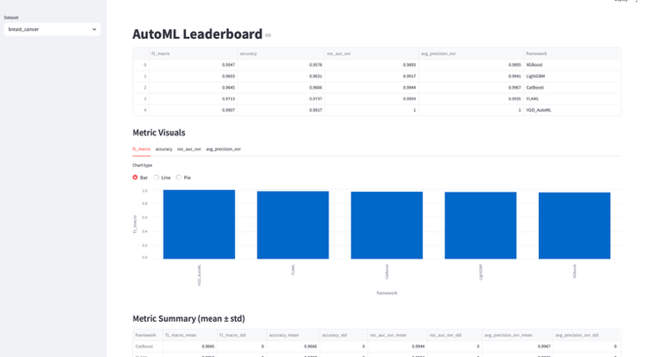
Figure 7: Streamlit Dashboard Screenshot

3.16 REPRODUCIBILITY AND EXPERIMENT MANAGEMENT
Reproducibility is a central goal of the benchmark. All experiments follow fixed seeds, predefined configuration files, and deterministic dataset splits to ensure that results can be regenerated exactly. Users can reproduce an entire experiment suite using a single command

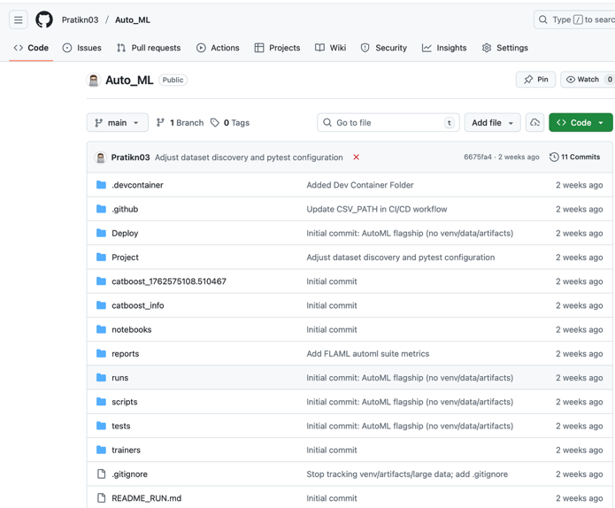
Figure 8: GitHub Desktop Screenshot

4. EXPERIMENRAL RESULTS
The benchmark was evaluated on tabular classification datasets using a standardized preprocessing pipeline, guardrail checks, and 5-fold cross-validation. Each dataset varies in size and feature composition, providing a diverse set of conditions for evaluating the boosting models and AutoML frameworks. All models were trained on identical splits and the same time budgets, ensuring that differences in performance reflect model capability rather than variation in the training process.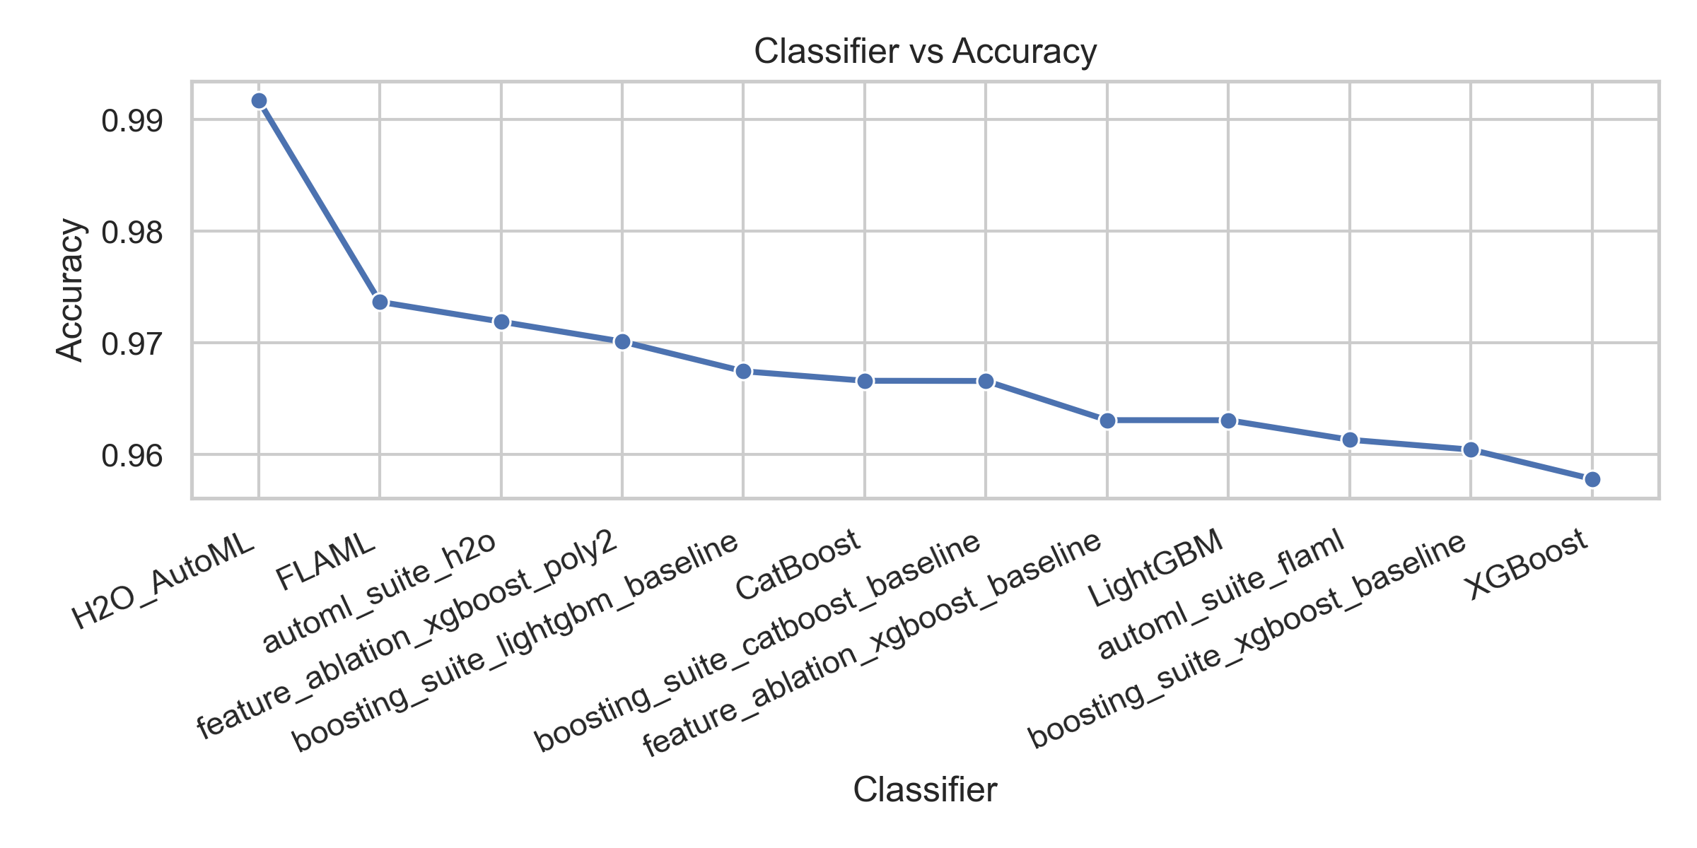
Figure 9: Classifier vs Accuracy
The model also provided the precision for different framework and boosting as showed in the graph below
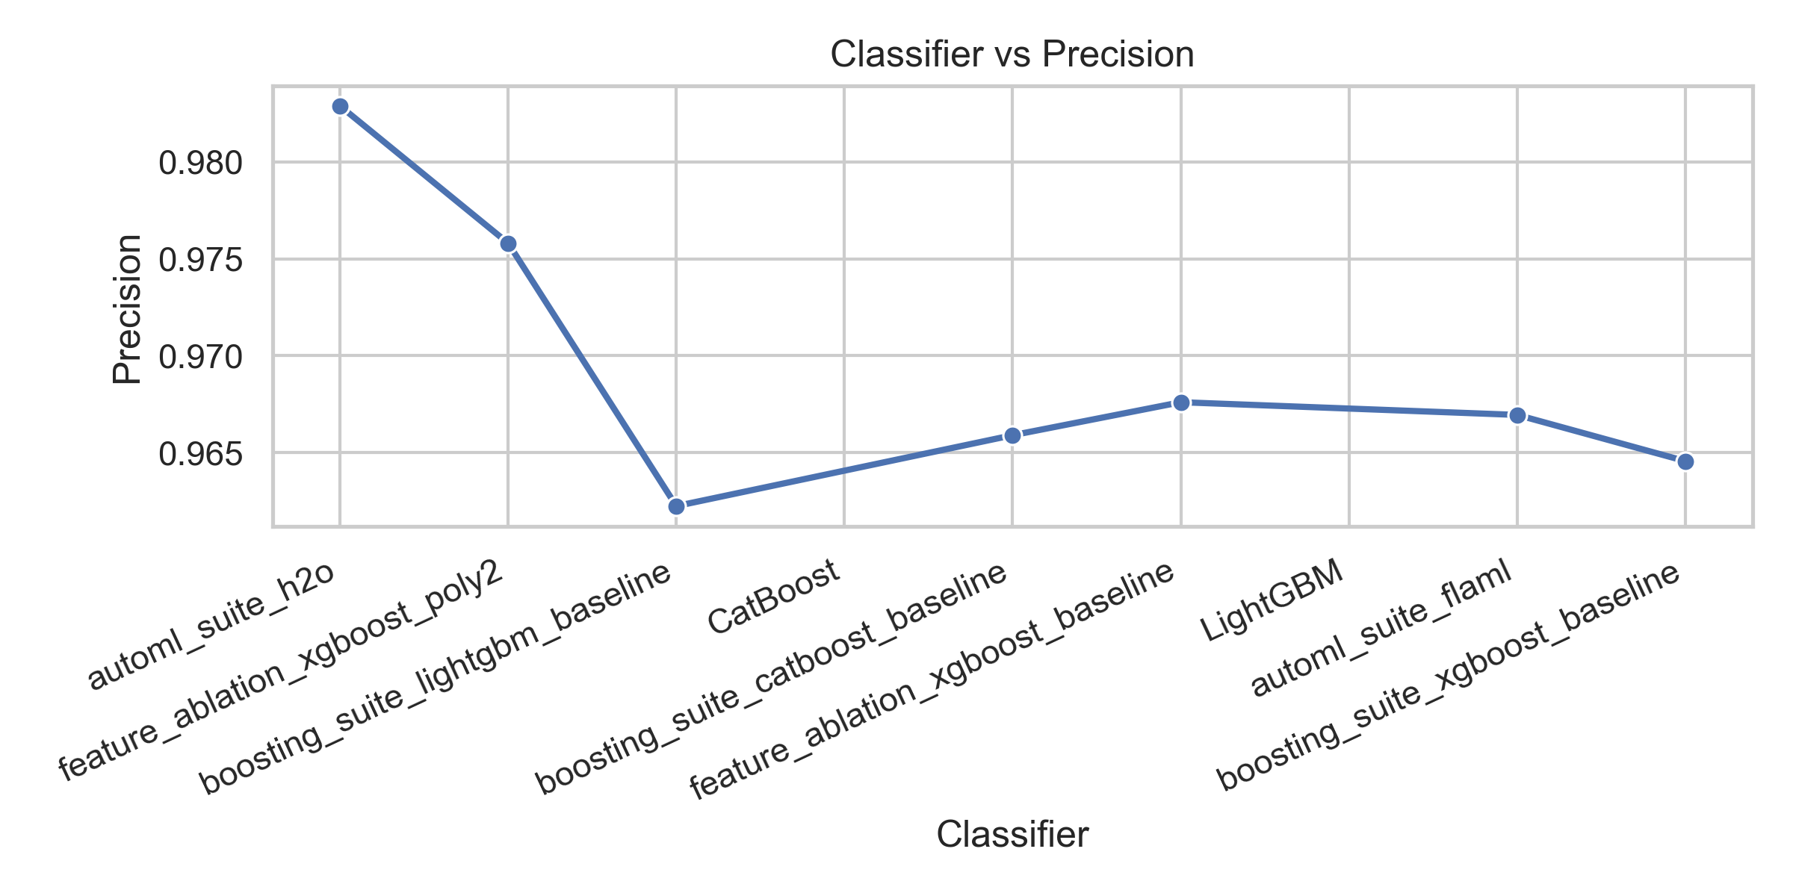
Figure 10: Classifier vs Precision
To compare accuracy, precision, recall and F1 score more easily we can use a histogram shown below,
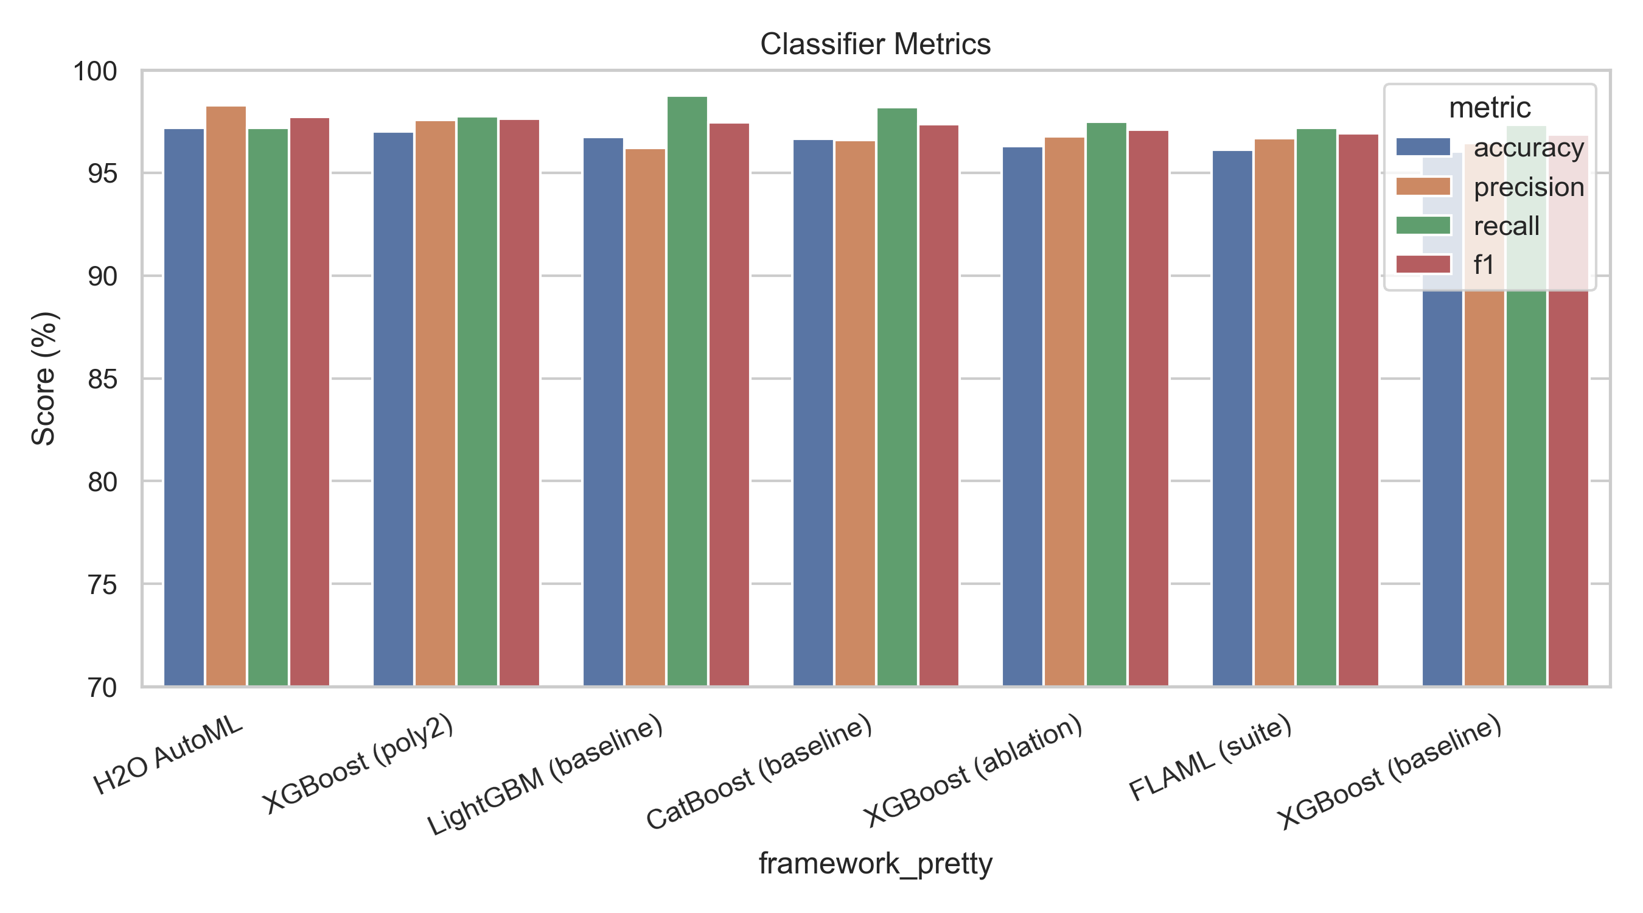
Figure 11: Classifier Visualized
From the figure above, we can clearly observe how each classifier performs across the different evaluation metrics. The accuracy plot shows that H2O AutoML achieves the highest mean accuracy (around 97.2%), followed closely by the XGBoost (poly2) ablation model. The LightGBM and CatBoost baselines form the next tier, showing strong and consistent performance. The precision plot follows the same trend, where H2O AutoML and XGBoost (poly2) again appear at the top, with LightGBM and CatBoost close behind.
When we compare all four metrics together in the grouped bar chart, the ranking becomes even clearer. H2O AutoML remains the best overall performer across Accuracy, Precision, Recall, and F1 Score, while XGBoost ,LightGBM, and CatBoost deliver competitive and balanced results. In contrast, the baseline XGBoost and FLAML variants show slightly lower scores across all metrics, although the differences are not very large. Overall, the figures show that the top classifiers maintain strong and consistent performance, while the lower-ranked models exhibit modest gaps between Precision, Recall, and F1 Score.
Data Collection:
The following image has the code with 210 lines for the data collection from different modules
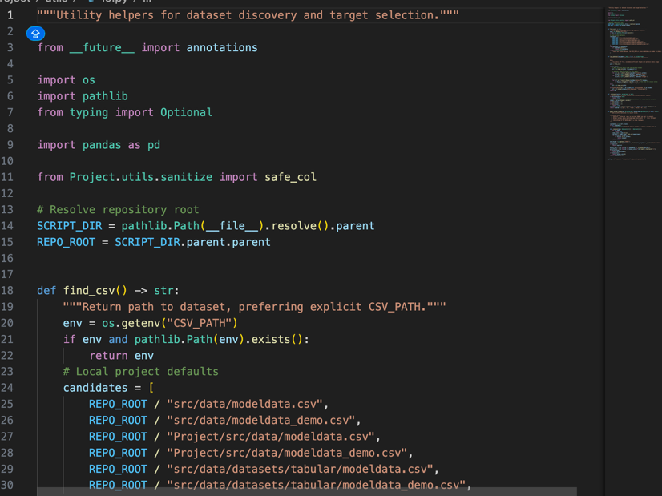
Figure 12: Data Collection
Data Processing: The following code of Data Processing contains about 53 lines of code
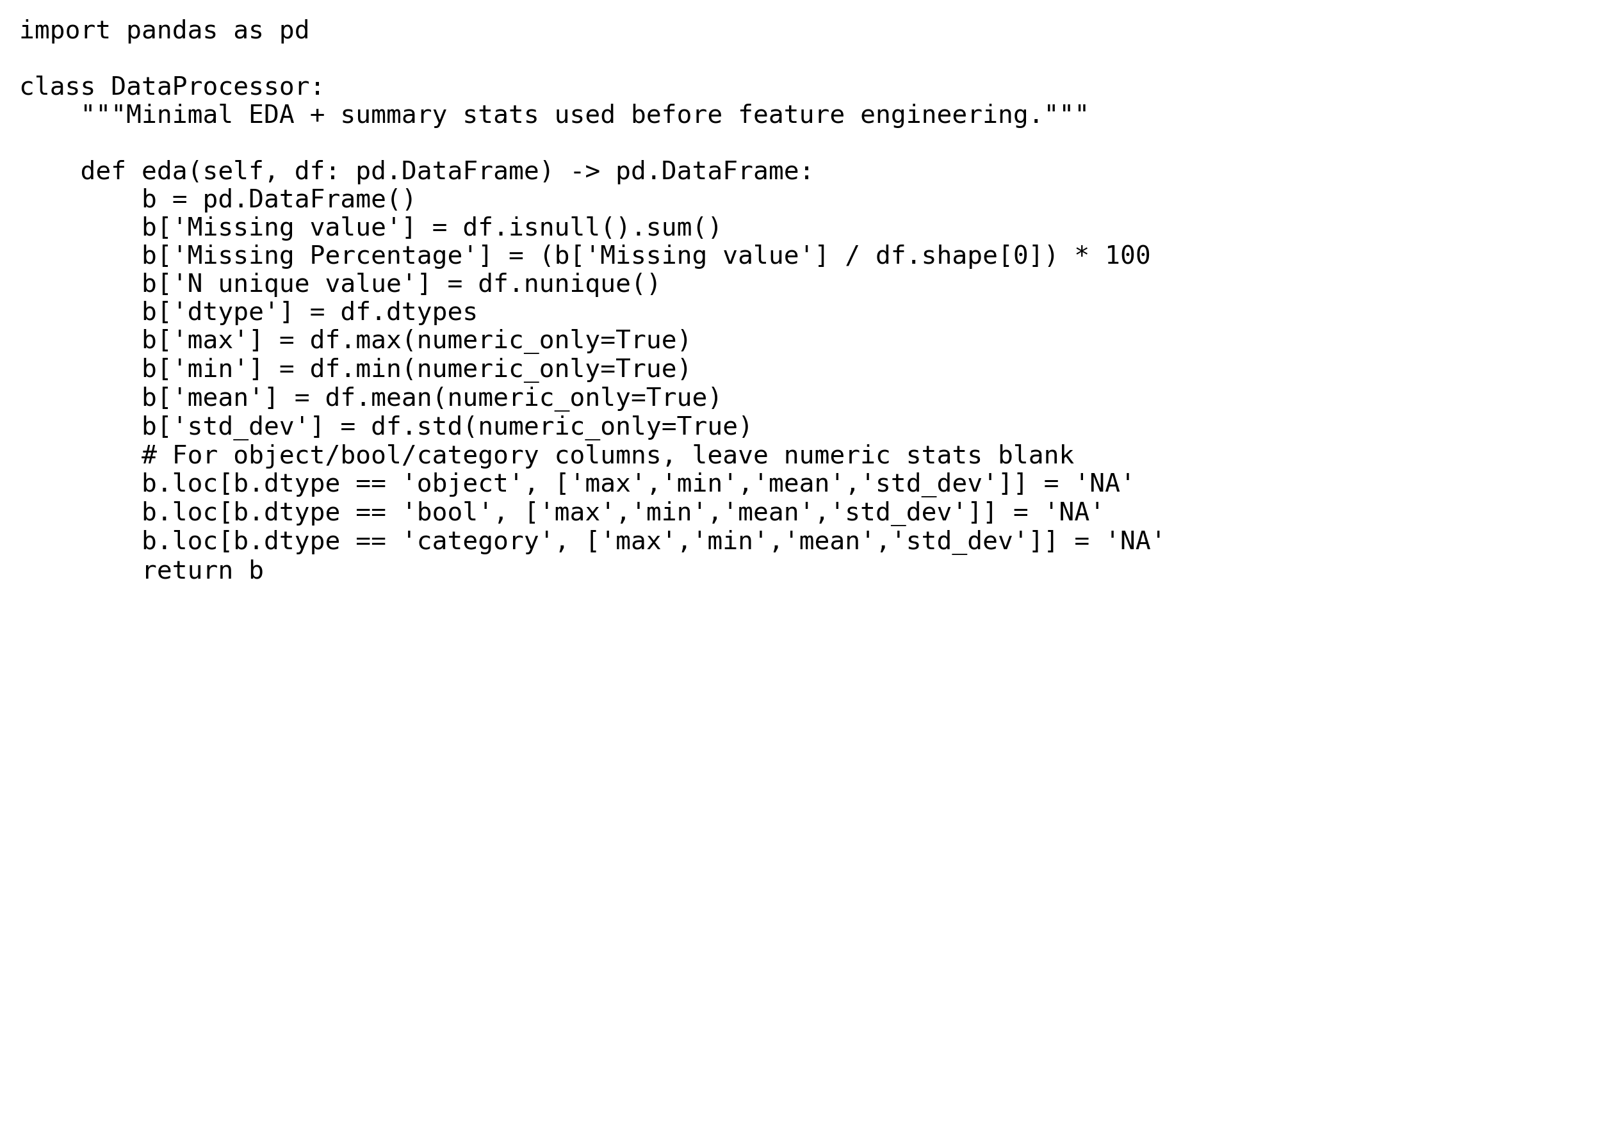
Figure 13: Data Processing

Guardrails / Leakage Check:
This script is specifically designed to audit for cross-fold duplicates, temporal leakage, and other leakage risks before training.
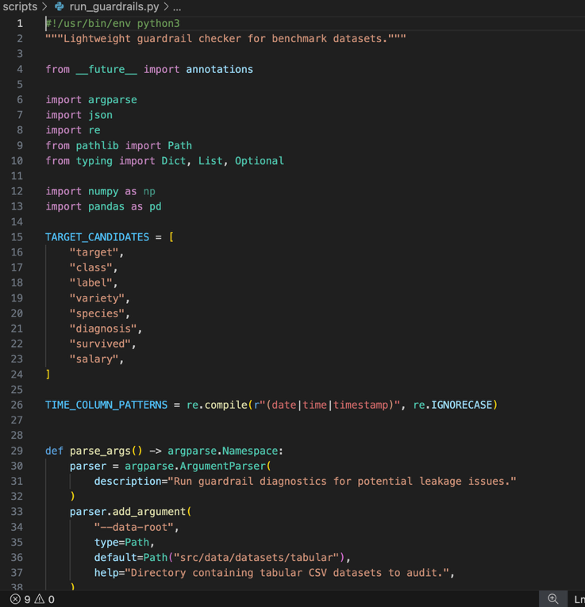
Figure 14: Guardrails / Leakage Check
Metrics Analysis:
The following code is responsible for analyzing all the results and summarizing the metrics. It loads the outputs from different models and experiments, computes metrics like accuracy, F1, ROC-AUC, etc., and aggregates them into summary tables or leaderboards. 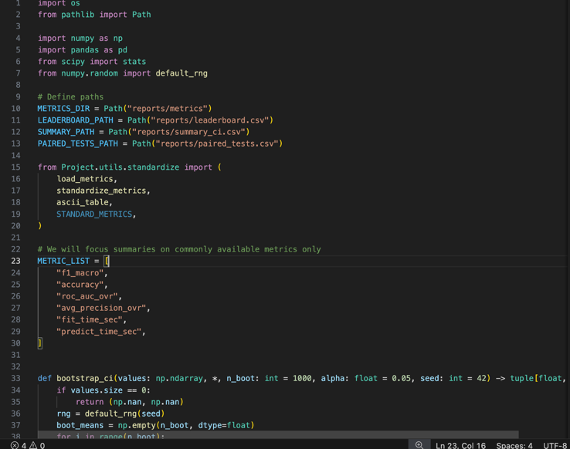
Figure 15: Metrics Analysis
Variance Inflation Factor: The following code for Variance Inflation Factor removes the multicollinearity from the model
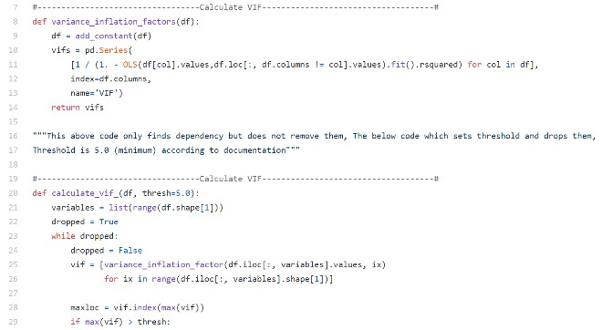Figure 16: VIF New

Feature Engineering:
The following code helps automate and standardize data cleaning and feature selection, especially by removing redundant features that could harm model performance due to multicollinearity.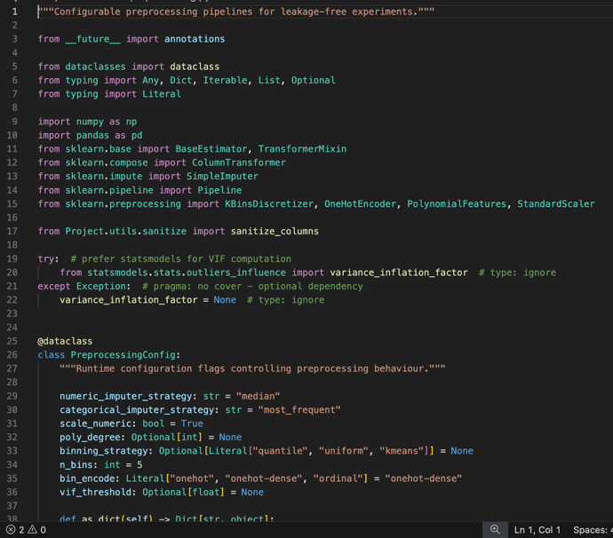
Figure 17: Fetaure Engineering:

Feature Generation:
The following code contains the new feature generation code that will help to make the model more accurate.

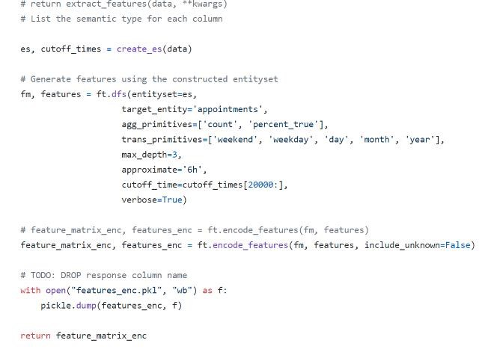
Figure 18: New Feature Generation
AutoML/booster loaders/Trainer:
The following code contains the snippet shows how all boosters and AutoML frameworks are executed under shared CV, time budgets, and seeds.
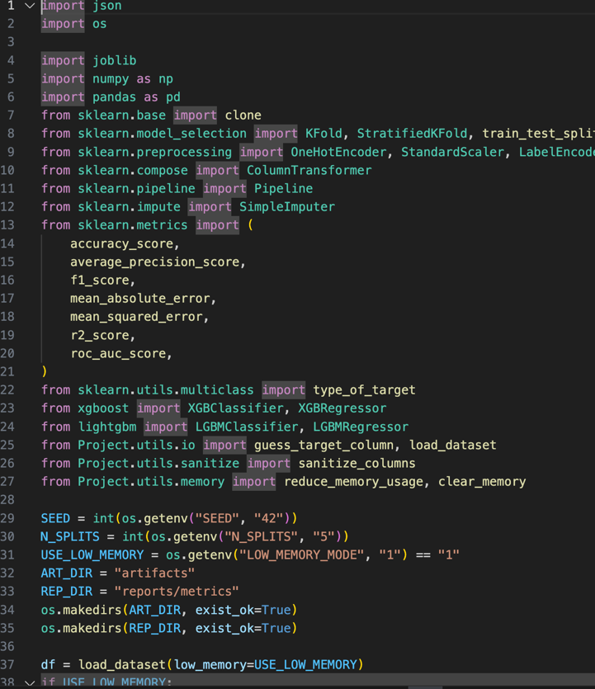 Figure 19: AutoML/booster loaders and Trainer

Streamlit leaderboard: The following code contains code of around 205 which runs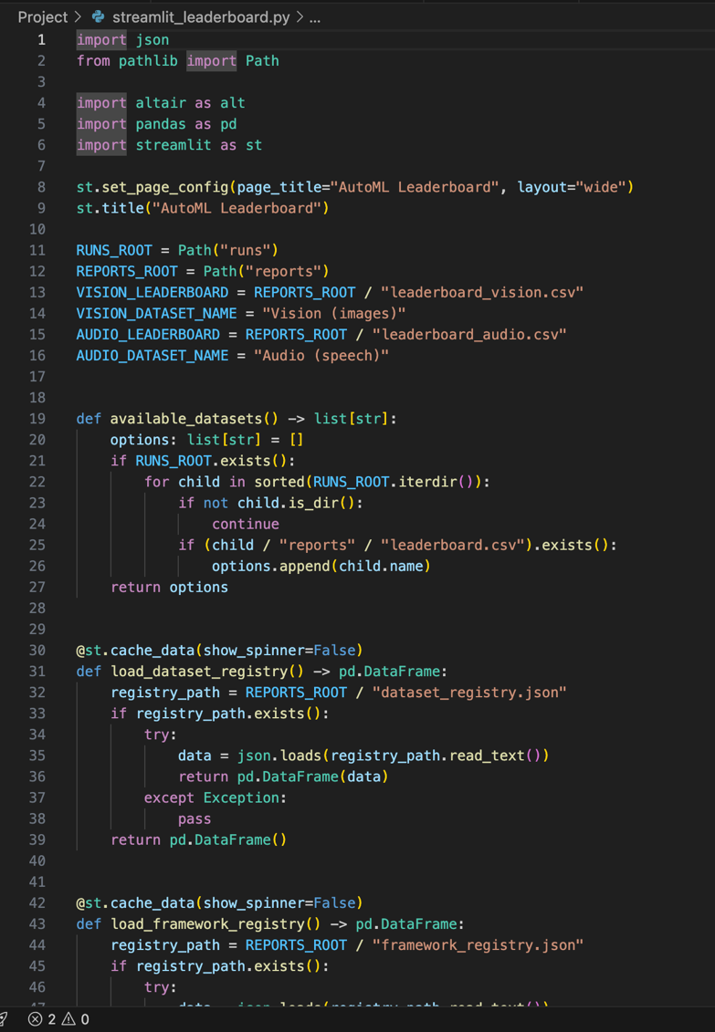
Figure 20: Streamlit Dashboard code

Reproducibility:
The following code contains code of around 205 which runs discovers datasets, runs every training/evaluation script in order, and archives outputs.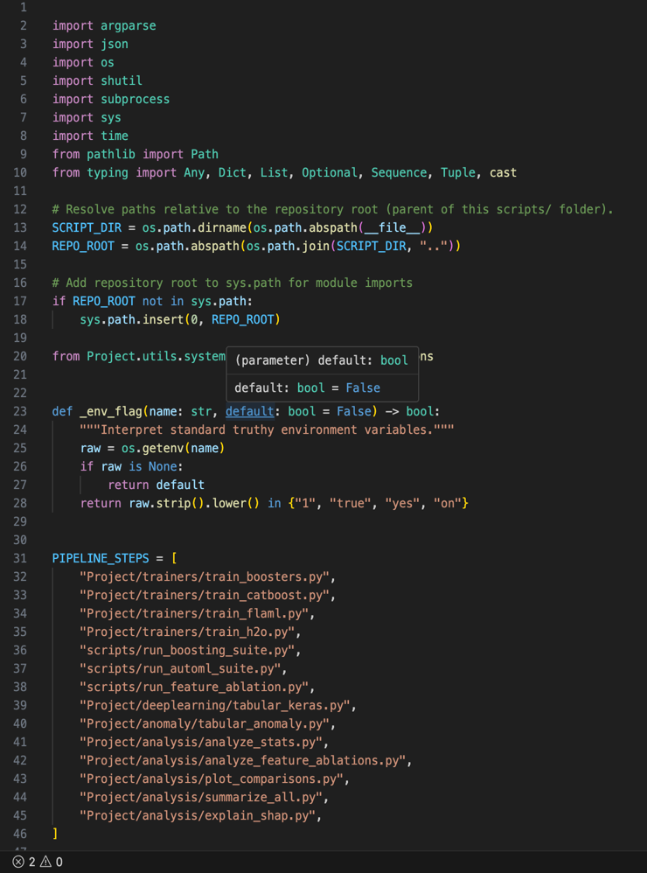
Figure 21: Reproducibility code Snippet

5. FUTURE WORK
There are many opportunities to extend this benchmark. On the modality side, adding richer text and audio tracks would make it possible to evaluate end-to-end fine-tuning for vision and multimodal tasks, not just compact CNN baselines. Robustness and fairness tests could be integrated to assess how models handle distribution shifts or group-level performance differences.
Extending the dataset suite to include more tabular, image, and time-series data—while keeping the same leakage-audited guardrails—would significantly broaden the applicability of the system.

6. CONCLUSION
The rapid growth of data and the increasing complexity of modern machine learning workflows have made automation essential for developing scalable and reliable models. This work presented a leakage-audited AutoML benchmark that unifies data collection, preprocessing, feature engineering, cross-validation, model training, explainability, and deployment within a single, reproducible pipeline. By incorporating strict guardrails, standardized folds, and consistent runtime budgets, the system ensures fair comparisons across both modern AutoML frameworks and strong boosting baselines.
The benchmark demonstrates that automated systems such as H2O AutoML, AutoGluon, LightAutoML, and FLAML can achieve performance comparable to or exceeding traditional boosting models like XGBoost, LightGBM, and CatBoost when evaluated under equal conditions. The pipeline also integrates SHAP-based explainability, runtime and latency logging, and deployment-ready artifacts, making the system useful not only for research but also for real-world applications. With its modular design, open-source structure, and end-to-end reproducibility, this framework provides a solid foundation for future work in trustworthy AutoML, expanded dataset coverage, and more advanced production-oriented evaluation.

8. REFERENCES
- Baker, Bowen, et al. "Accelerating neural architecture search using performance prediction." arXiv preprint arXiv:1705.10823 (2017).
- Nargesian, Fatemeh, et al. "Learning Feature
Engineering for Classification." IJCAI. 2017. [3] Pranckevičius, Tomas, and Virginijus Marcinkevičius. "Comparison of naive bayes, random forest, decision tree, support vector machines, and logistic regression classifiers for text reviews classification." Baltic Journal of Modern Computing 5.2 (2017): 221.
- Vakili, Meysam, Mohammad Ghamsari, and Masoumeh Rezaei. "Performance Analysis and Comparison of Machine and Deep Learning Algorithms for IoT Data Classification." arXiv preprint arXiv:2001.09636 (2020).
- Wistuba, Martin, Nicolas Schilling, and Lars SchmidtThieme. "Hyperparameter optimization machines." 2016 IEEE International Conference on Data Science and Advanced Analytics (DSAA). IEEE, 2016.
- Yao, Quanming, et al. "Taking human out of learning applications: A survey on automated machine learning." arXiv preprint arXiv:1810.13306 (2018).
- Elshawi, Radwa, Mohamed Maher, and Sherif Sakr. "Automated machine learning: State-of-the-art and open challenges." arXiv preprint arXiv:1906.02287 (2019).
- Wirth, Rüdiger, and Jochen Hipp. "CRISP-DM: Towards a standard process model for data mining." Proceedings of the 4th international conference on the practical applications of knowledge discovery and data mining. London, UK: Springer-Verlag, 2000.
- He, Xin, Kaiyong Zhao, and Xiaowen Chu. "AutoML: A Survey of the State-of-the-Art." Knowledge-Based Systems (2020): 106622.
- Zöller, Marc-André, and Marco F. Huber. "Survey on automated machine learning." arXiv preprint arXiv:1904.12054 9 (2019).
- Erickson, N., Mueller, J., Zhang, H., Li, Z., Smola, A., & DeCoste, D. (2020).AutoGluon-Tabular: Robust and accurate AutoML for structured data. arXiv preprint arXiv:2003.06505.
- Prokhorenkova, L., Gusev, G., Vorobev, A., Dorogush, A.V., &Gulin,A.(2018). CatBoost: Unbiased boosting with categorical features. Advances in Neural Information Processing Systems, 31.

